**<** **Visualization of global COVID-19 data on maps >**

**System Design Specification (SDS)**

**<Version #>**

**3.0**

**<Date>**

**2021/6/1**

<Project team members>

**陈可轩1930026012**

**戴靓1930026020**

**李涵1930026064**

**齐子瞻1930026109**

**吴越1930001085**

**Computer Science and Technology Program**

**United International College**

1. Document Change Log

|  |  |  |  |
| --- | --- | --- | --- |
| ***Change Date*** | ***Changed By*** | ***Version*** | ***Change Description*** |
| *01/07/2012* | *Lisa Lee* | *1.0* | *Prepared Document* |
| *05/09/2021* | *All group members* | *2.0* | *Prepared basic information* |
| *06/01/2021* | *All group members* | *3.0* | *Change some graphs and some introduction* |
|  |  |  |  |
|  |  |  |  |
|  |  |  |  |
|  |  |  |  |
|  |  |  |  |
|  |  |  |  |
|  |  |  |  |

1. Table of Contents

1. Document Change Log 2

2. Table of Contents 3

3. Design Overview 4

4. Tools and Standards 5

4.1. Tools 5

4.2. Standards 5

5. User Interface Design 6

5.1. Usage Scenario 1 6

5.2. Usage Scenario 2 6

6. Database Design 7

7. Diagrams 8

1. Design Overview

Through data visualization, we would show the changes of the number of patients who suffer from novel coronavirus and cured in countries all over the world. Some countries and regions with serious epidemic situation can be reflected by color shade and emphasis by the visualization in our group. Our project will target some news lovers or the public who still think the novel coronavirus is not important, and conclude that the novel coronavirus is serious and spread quickly, and should not be cheated by some foreign media with ulterior intentions.

We will use python and related packaging such as pandas, numpy, openpyxl, xlrd, pyecharts, matplotlib, IPython, webbrowser, tkinter, requests, json, folium and so on to finish the project, we may make changing if needed. And our groupmates will all participate in this group project.

1. Tools and Standards

## Tools

We mainly use pycharm as our tools. And we use packages such as Pandas, Xlrd, Openpyxl, pychars for data analysis and visualization. Packages like matplotlib, pyecharts, matplotlib, IPython, webbrowser, tkinter, requests, json, folium for data visualization.

## Standards

Runs on the windows platform and mac os.

1. User Interface Design

## Usage Scenario 1

The final image we're going to render is going to look something like this：

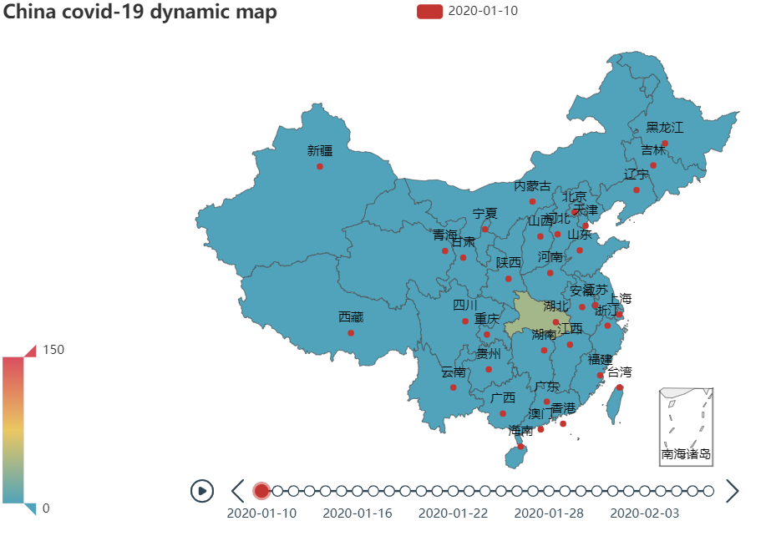

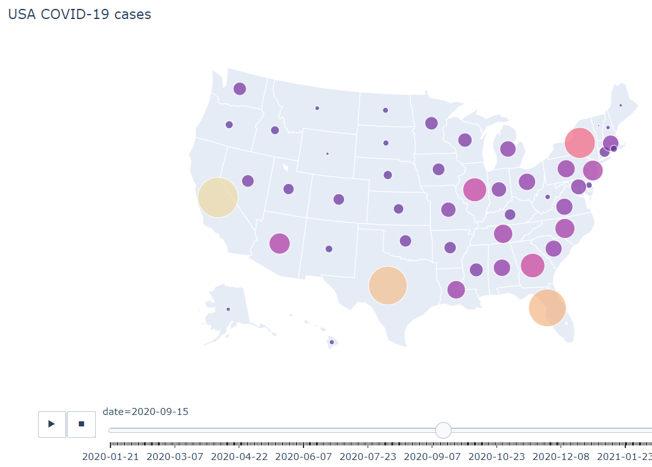

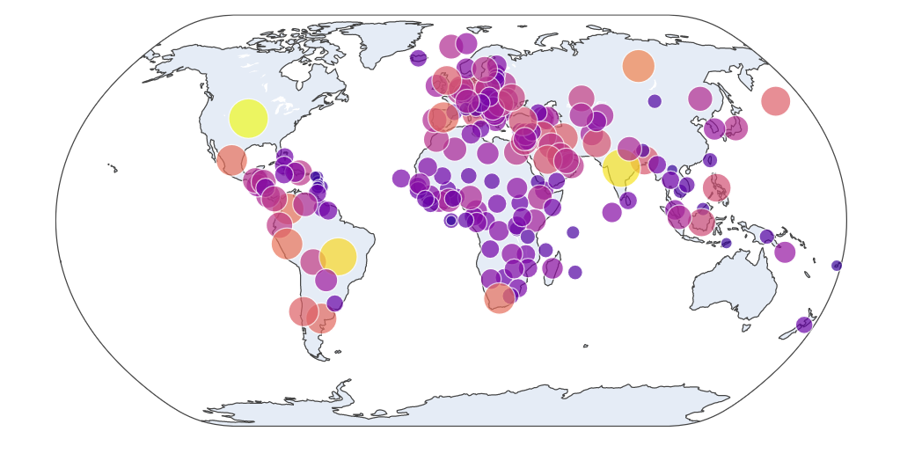

Our image will show the national and global epidemic map over time. Users can view the epidemic data of each location on the map at each time period by moving the mouse. You can present multiple maps at the same time or only show one map over time. If the map changes over time, we will provide the option to change the time or allow the map to change automatically over time, and the changes will stop when the user is looking at the map.

## Usage Scenario 2

The global pandemic map would look something like this. And it would be changed followed by date. We will also have a visual map to show the each countries changing rate.

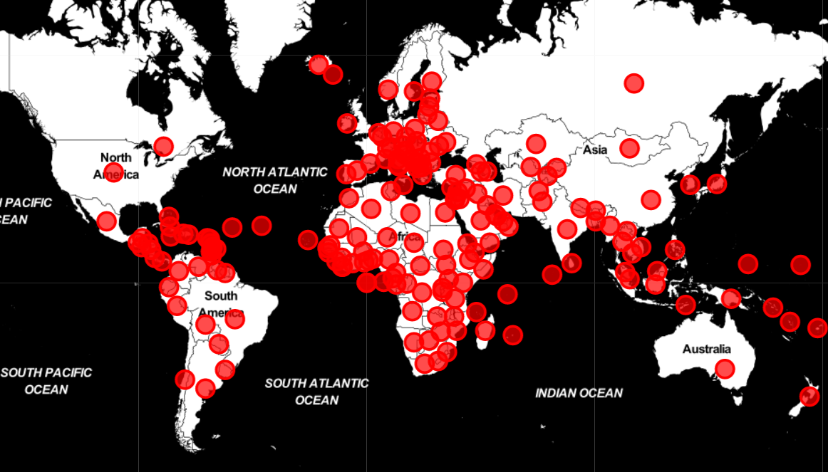

## 5.3 Histograms of COVID-19 in China

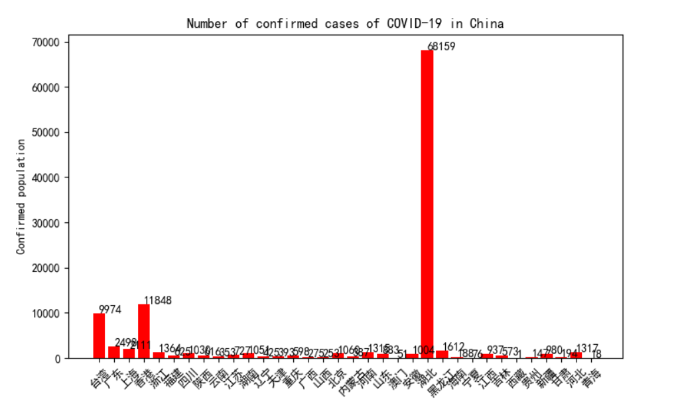

## 5.4 Animation of global COVID-19 changes

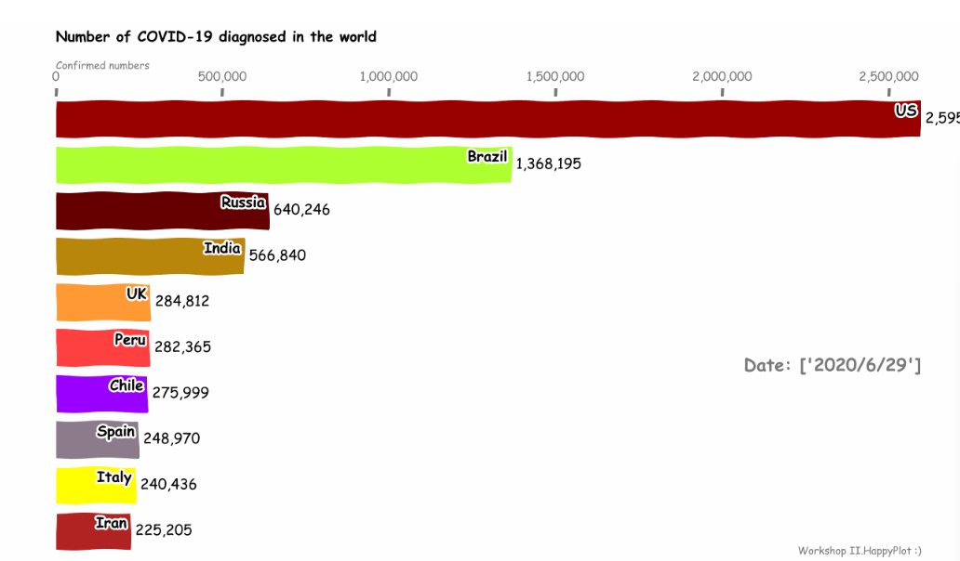

1. Database Design (If Applicable)

*No database*

1. Diagrams

*<C Programming course: Control Flow diagram; Java: Class Diagram>*

## 